Social Media Toolkit: National Apprenticeship Week
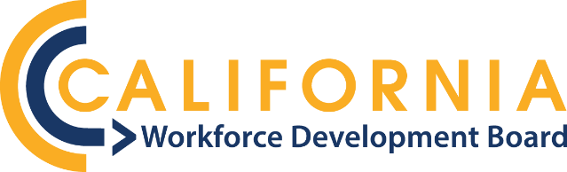
A California economy defined by equity, quality jobs and climate resiliency.

National Apprenticeship Week 2023
Social Media Action Toolkit
Background
National Apprenticeship Week (NAW) is a nationwide celebration established by the U.S. Department of Labor where employers, industry associations, labor organizations, community-based organizations, workforce partners, education providers, and government leaders host events to showcase and promote high-quality, inclusive, in-demand career pathway opportunities through Registered Apprenticeship. Additionally, NAW provides apprentices a platform to share their apprenticeship experience and how it has transformed their lives.

The California Workforce Development Board (CWDB) supports and funds apprenticeships and pre-apprenticeship training throughout the state. Apprenticeships are a longstanding and extremely effective set of career ladders providing pathways to the middle class. Pre-apprenticeship increases access to these high-quality careers for populations that face barriers to employment and/or remain under-represented in the industry.
Objectives
- Highlight career opportunities available through apprenticeships.
- Highlight High Road apprenticeships throughout the state.
- Raise public awareness/support for apprenticeship training.
Target Audience
- Community colleges
- Local workforce development boards
- Elected officials
- Labor representatives
- Targeted industry sectors
- Reporters and news outlets
Tips and Tricks
- Mention or tag CWDB so we can reshare your post (Twitter and Instagram: @CA_WorkforceDev, and Facebook: @CaliforniaWorkforceDev).
- Use one of the sample posts provided below, or tell your own story!
- Post on as many social media platforms as you can - Twitter, Facebook, Instagram, and LinkedIn.

Pre-NAW Week Social Media Posts
1. National Apprenticeship Week #NAW2023 is coming. Mark your calendar for Nov 13-17, and use our @CA_WorkforceDev NAW toolkit to make it easy to post your apprenticeships and pre-apprenticeship celebrations and shoutouts.

2. Get ready for #NAW2023 next week. Download @CA_WorkforceDev’s NAW toolkit to make it easy to share apprenticeship and pre-apprenticeship stories, highlights, and shoutouts, and don’t forget to tag us.

NAW Week - General Messaging and Graphics
Note: Graphics 2 and 3 can be customized with your photos, names of apprentices, and their quotes on Canva.com. Email media@cwdb.ca.gov to gain access to these adaptable social cards.

1. 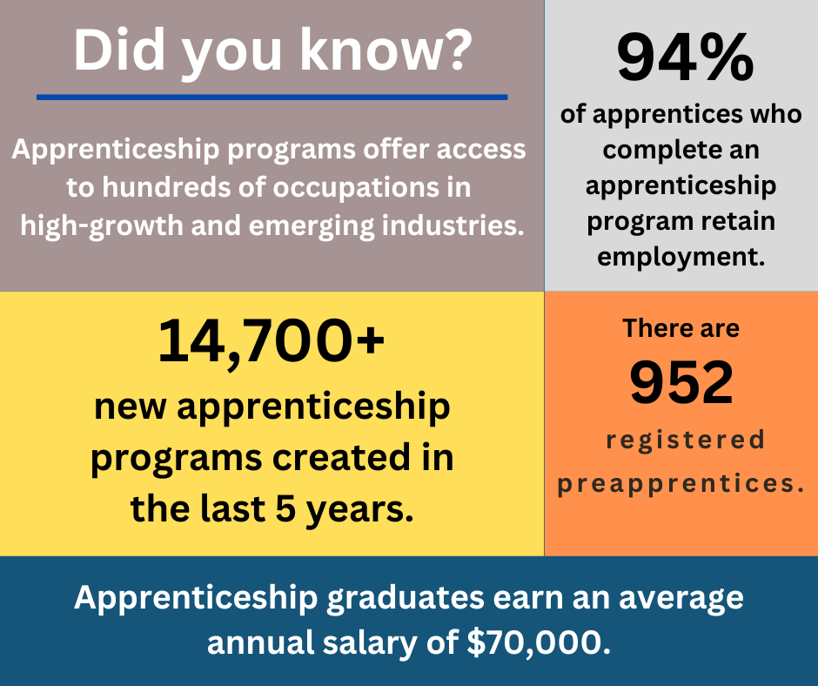

2. 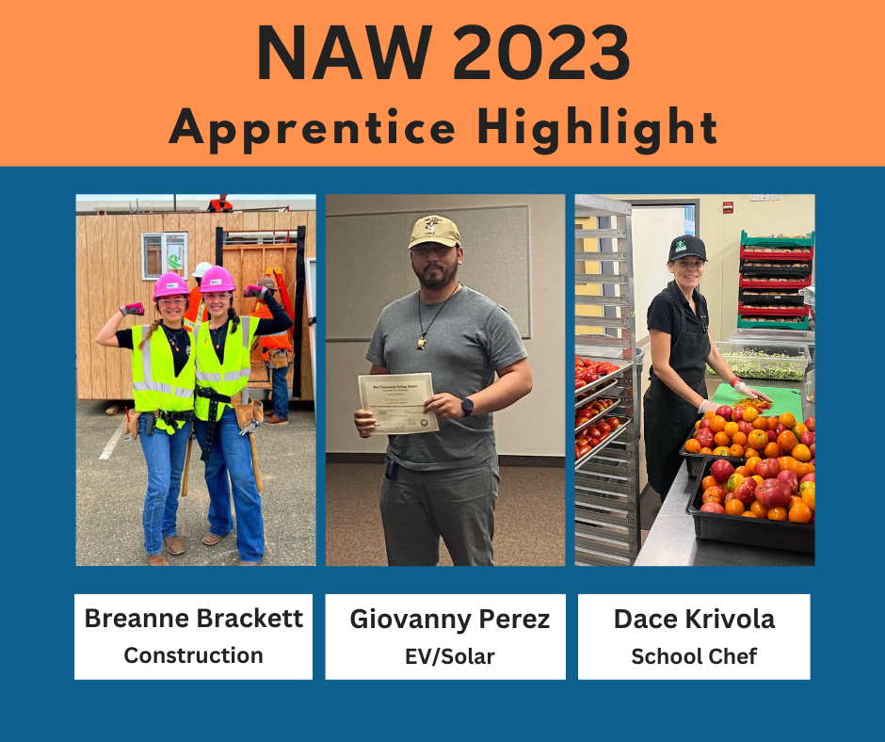

3. 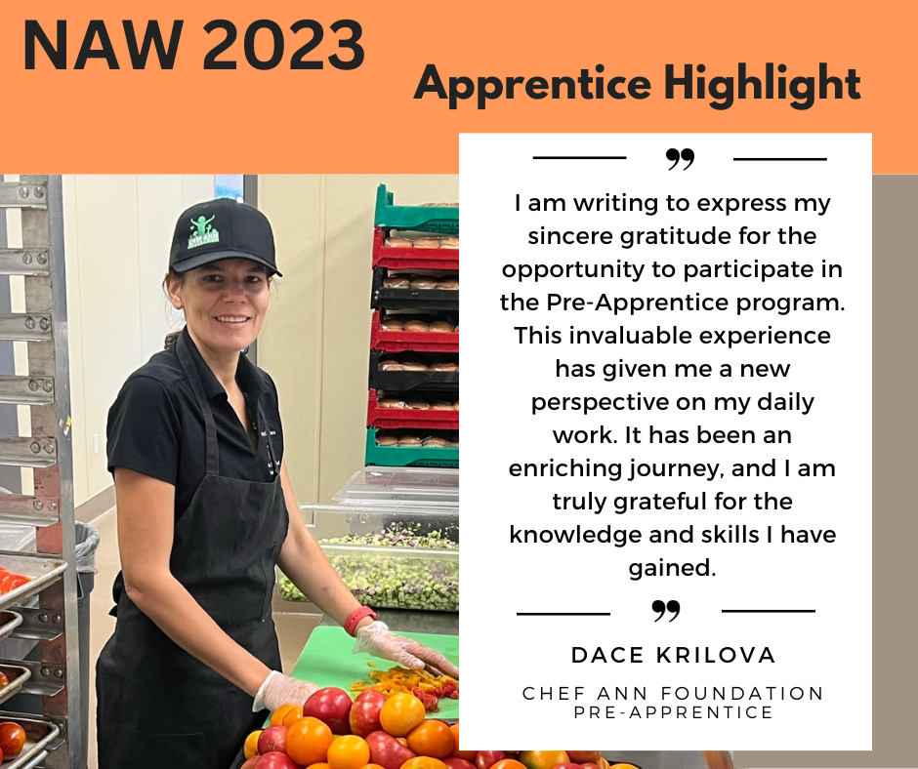 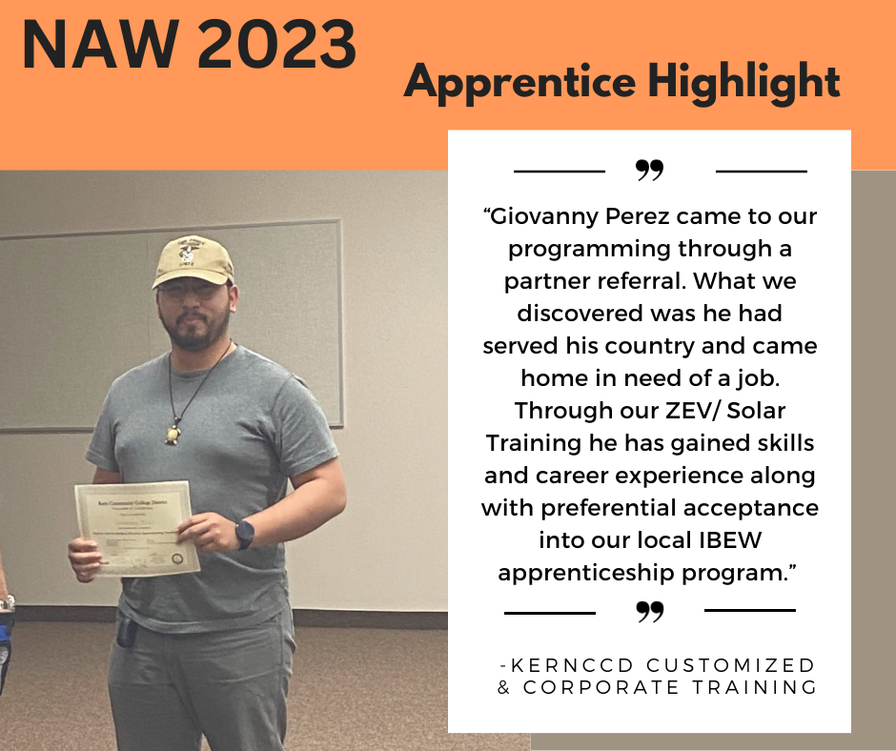

4. 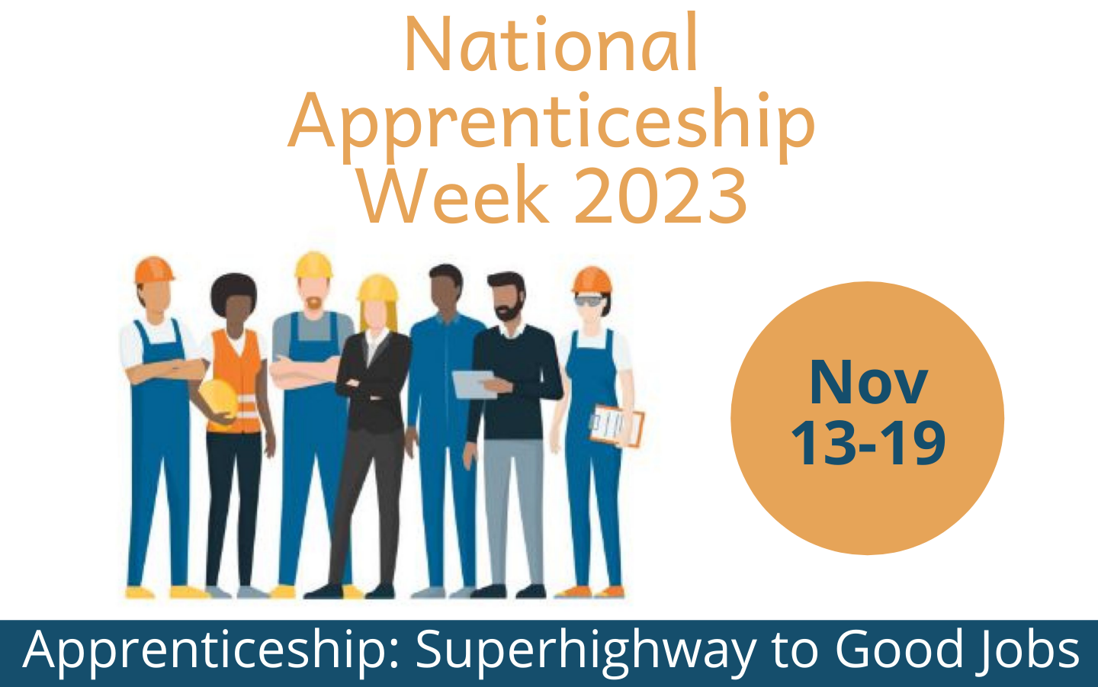

Sample Theme Day Posts

Monday, November 13: Apprenticeships for Youth
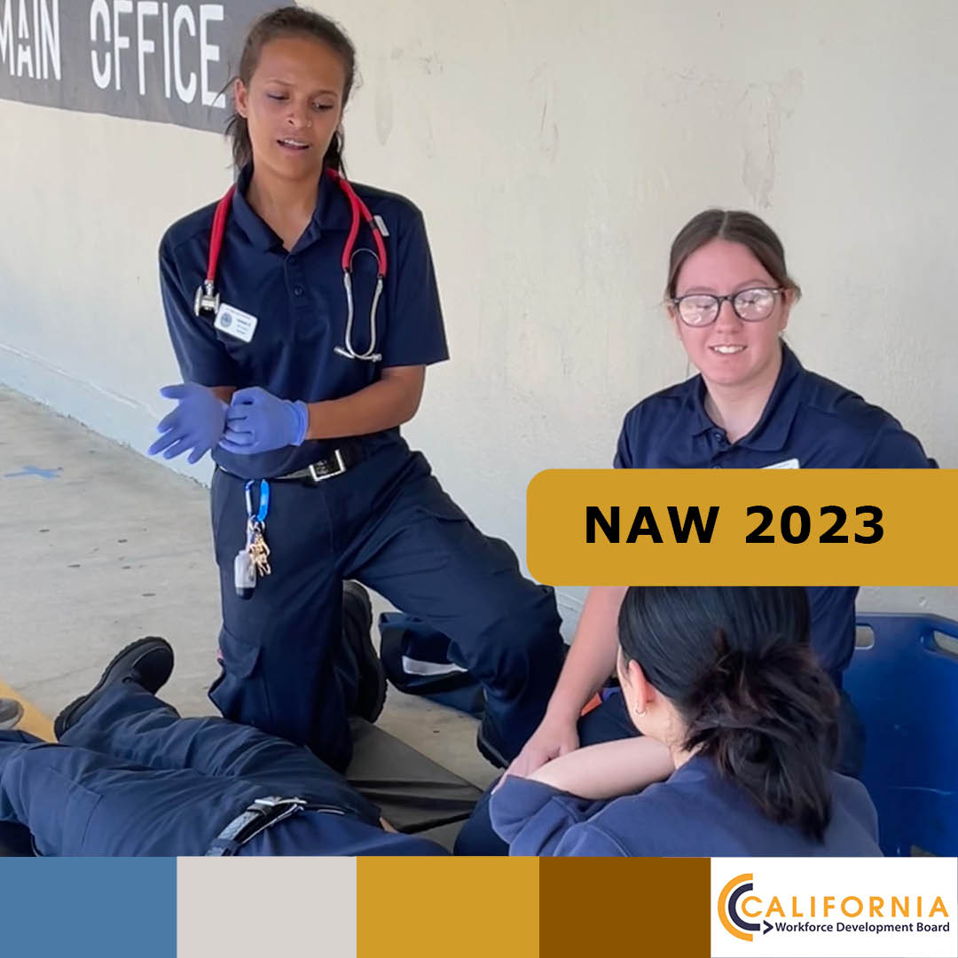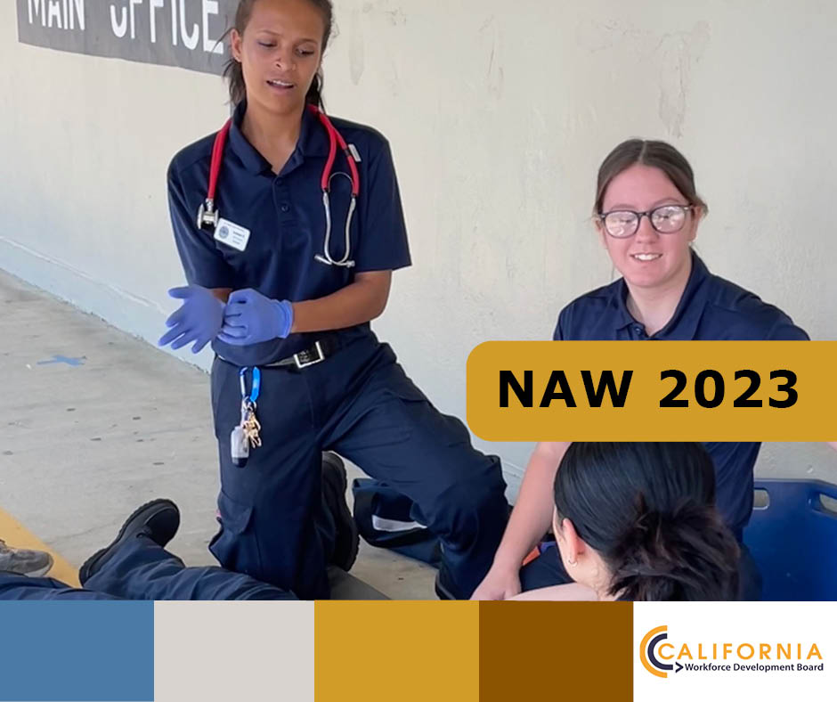
Instagram Facebook and Twitter
@WDBCCC’s Emergency Medical Technician (EMT) Paramedic Apprenticeship Program has carved out in-demand High Road career pathways for youths. The fact that participants earn a quality living while completing all the steps to go straight into a good-paying job as Licensed Paramedics is key to participant success and completion.

#youthemployment, #youthapprenticeships, #HighRoad, #EducationFund

Tuesday, November 14: Apprenticeships in New and Emerging Industries
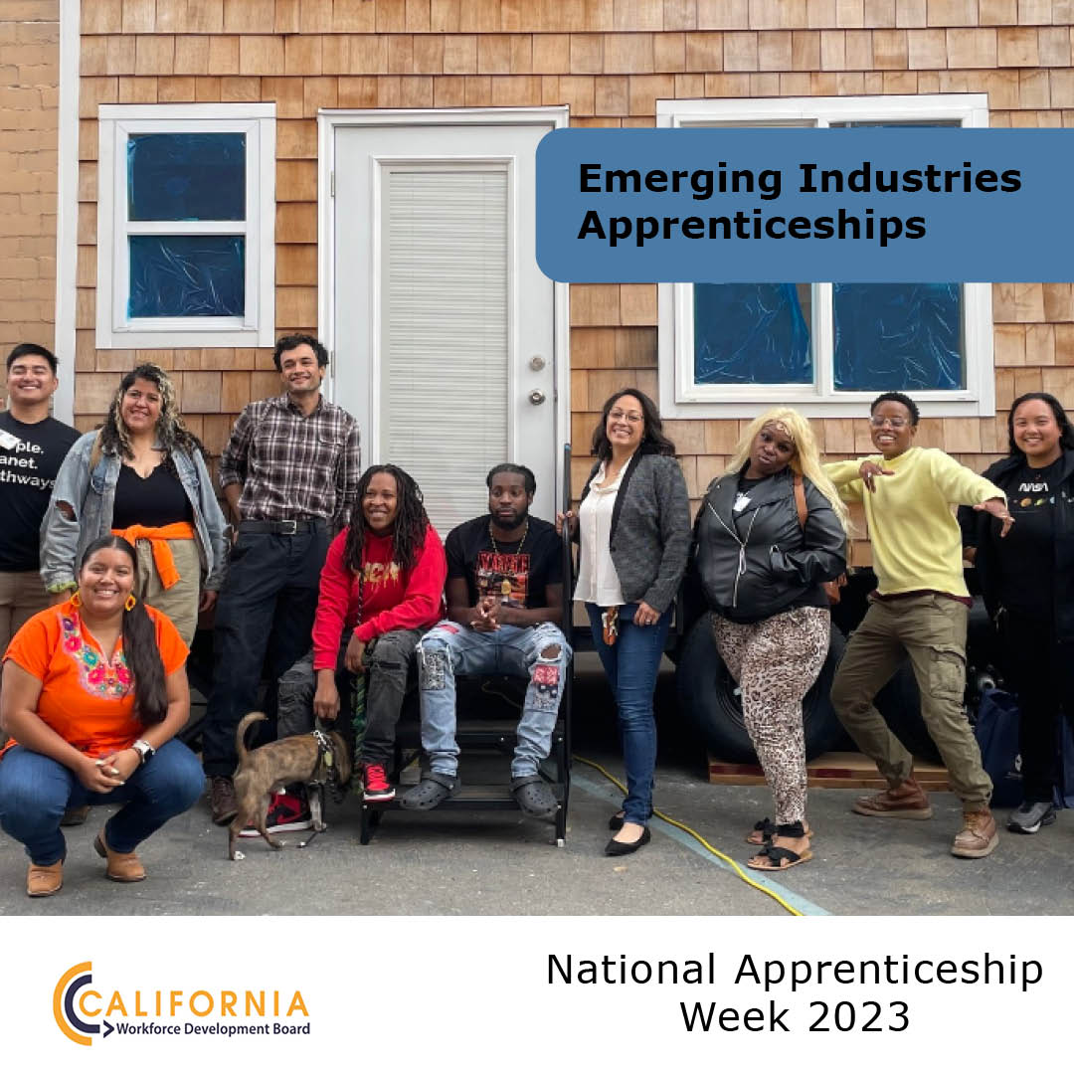
Facebook and Twitter Instagram

@CA_WorkforceDev’s HRTP partner @risingsunopp trains workers in new emerging energy industries with pre-apprenticeships focused on decarbonizing existing residential buildings. This work includes replacing appliances that run on fossil fuels with electric alternatives and general remediation needed to make these upgrades.
#climatejobs, #greenjobs, #climateaction, #HighRoad

Wednesday, November 15: Expanding Apprenticeships to Underserved Populations
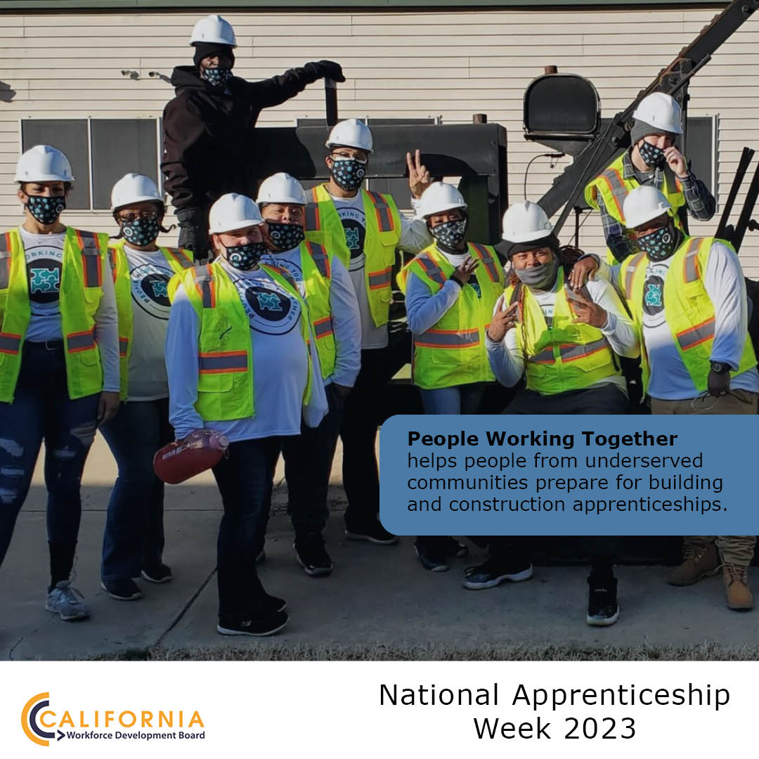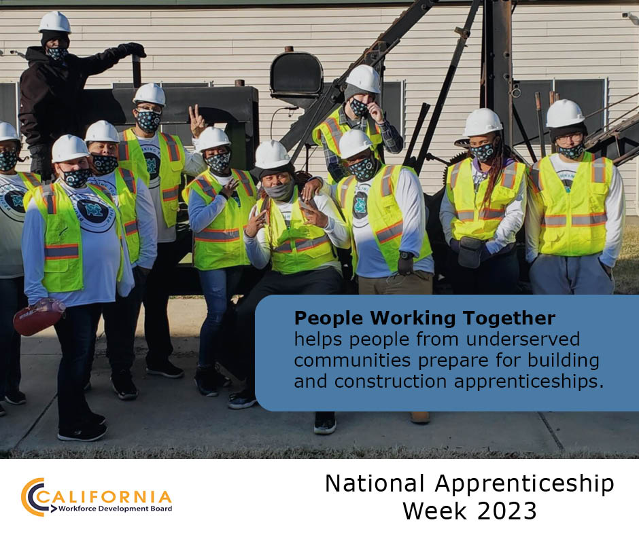
Instagram Facebook and Twitter

@CA_WorkforceDev celebrates #NAW2023 and its focus on expanding apprenticeships to underserved populations. Our HRTP partner @PWT916 does just that by targeting populations like justice-involved, immigrants, and economically disadvantaged for their pre-apprenticeship programs, which teach the Multi-Craft Core Curriculum.
#2023Apprenticeshipweek, #peopleworkingtogether

Thursday, November 16: Women in Apprenticeships

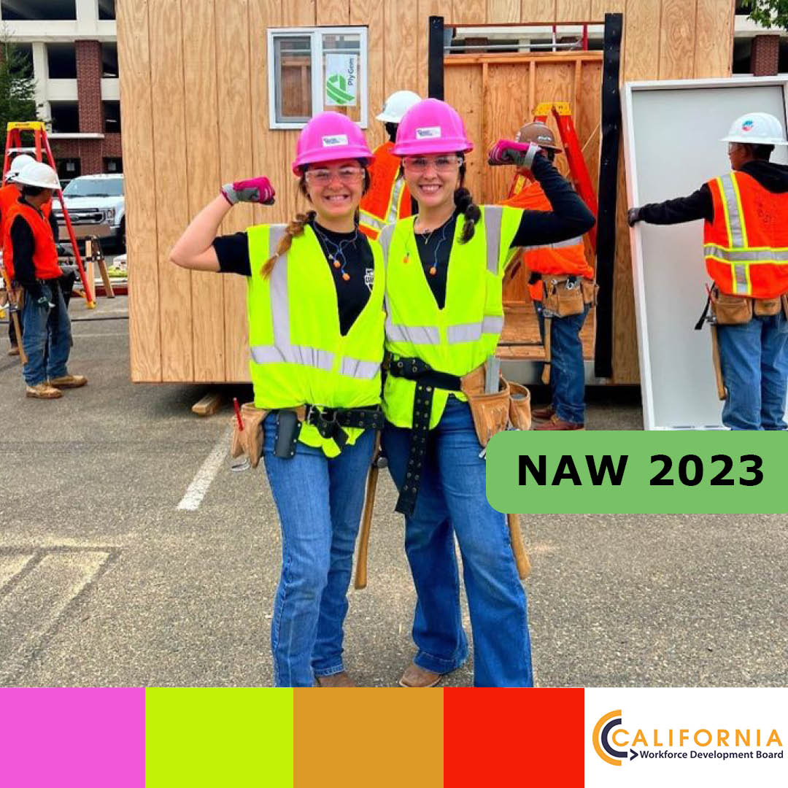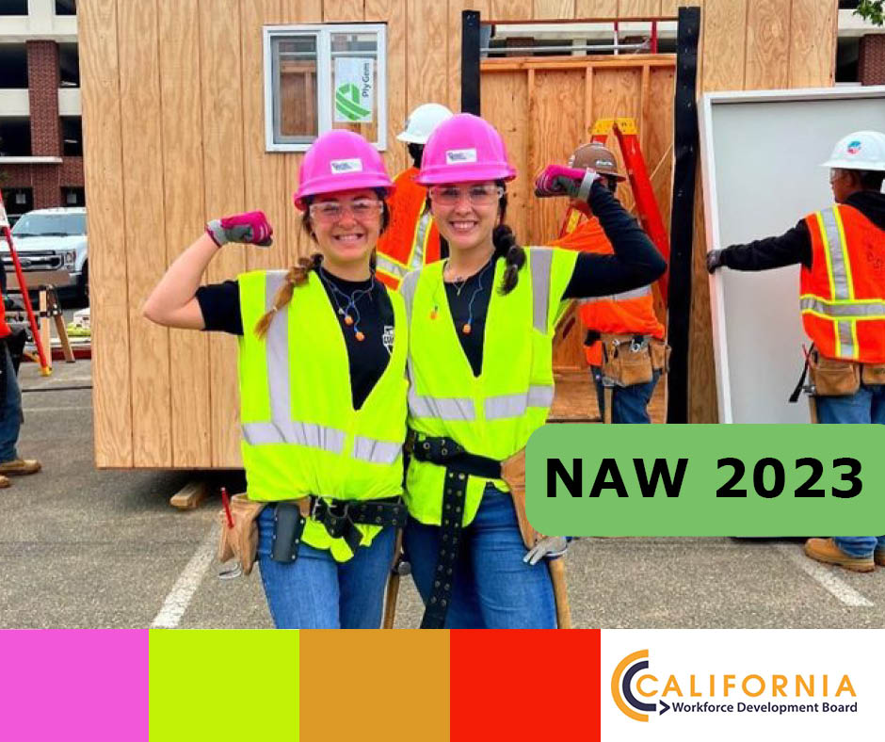
Instagram Facebook and Twitter

“The Women in Trades event helped shape my career trajectory. I have gained new perspectives and the confidence and willpower that I can and will be successful,” said Breanna Brackett. @kernccdtraining creates clear career pathways to self and family-sustaining wages through equity and access, and by eliminating barriers and building a village around the students.

#womenempowerment, #buildingtrades, #HRCC, #HighRoad

Friday, November 17: Apprenticeships for Veterans
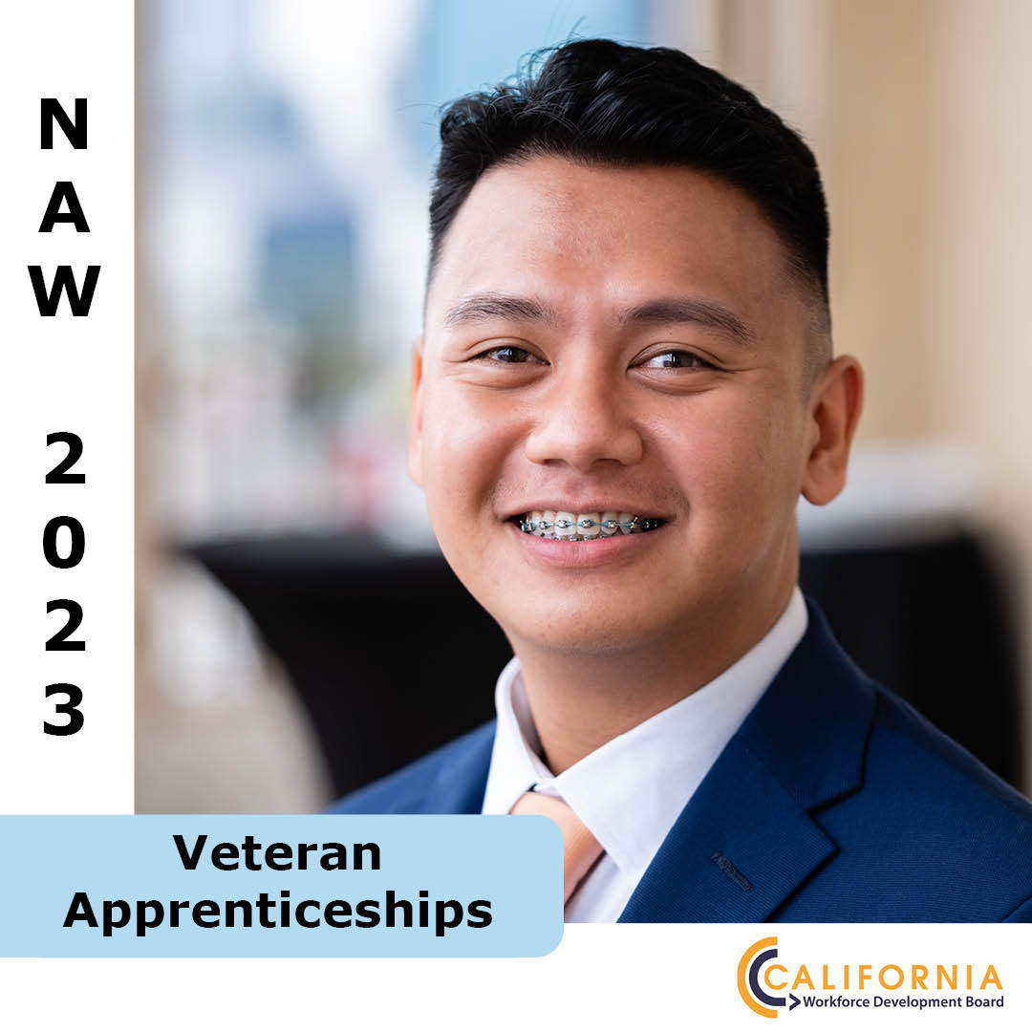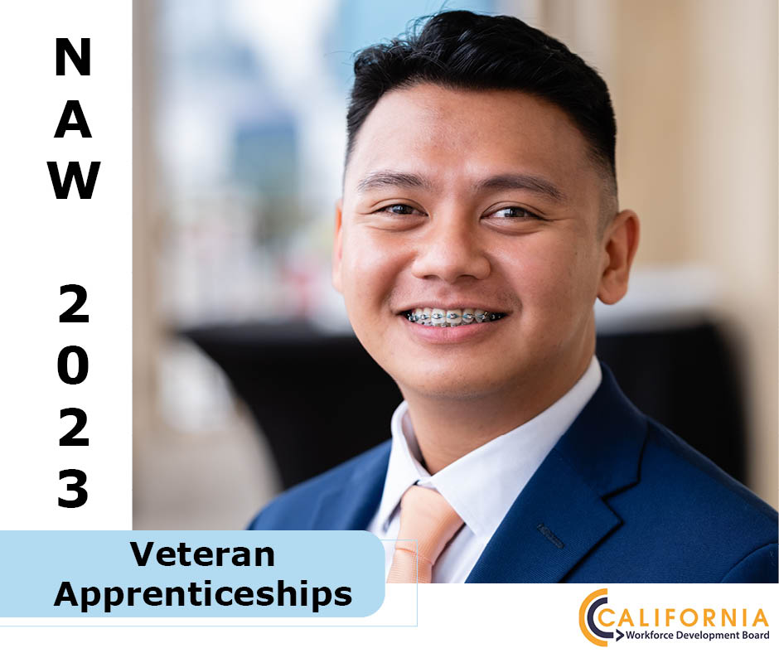
Instagram Facebook and Twitter

Audric Adarme went from the U.S. Navy Reserves to @NpowerOrg’s Tech Fundamentals training program, where he was provided with no-cost instruction, social support, professional development, and employment placement services. After graduating with industry-recognized certifications, Audric applied his new valuable skills in an NPower apprenticeship position.

#veterans, #veteransemployment, #2023Apprenticeshipweek, #HighRoad, #HRTP

Sample Interview Questions
- How did you feel after your first day of your pre-apprenticeship or apprenticeship
program?
- What was your favorite activity that you participated in?
- What’s one skill that you learned that you feel really helped you?
- Have you decided what you want to specialize in?
- How has the pre-apprenticeship/apprenticeship program impacted your life/changed your work trajectory?
- What will having a good-paying job mean to you and your family?

In-Person NAW Celebrations
Bay Area Construction Workforce Conference
Wednesday, Nov. 15, 9:00 AM- 3:30 PM
Cypress Mandela in Oakland, CA.

Learn about the construction industry, upcoming job demand, and how Alameda County engages new apprentices with strong labor policies and standards. Find out more here, or use the QR code below to register.

The Apprenticeship Connection Summit
Wednesday, Nov. 15, 8:00 AM- 12:30 PM
Mount San Jacinto College in Temecula, CA.

CWDB’s Paul Aguirre and Marc Cowan will talk about the current High Road Training Program projects in the Inland Empire area, and California Labor Secretary Stewart Knox will give a keynote speech on apprenticeships and workforce. Find out more here, or use the QR code below.

CWDB Social Media Handles
Social Media Platform | Handle
Twitter | @CA_WorkforceDev
Facebook | @CaliforniaWorkforceDev
Instagram | @CA_workforcedev
LinkedIn | @California_Workforce_ Development_Board
YouTube | @californiaworkforcedevelop7121

