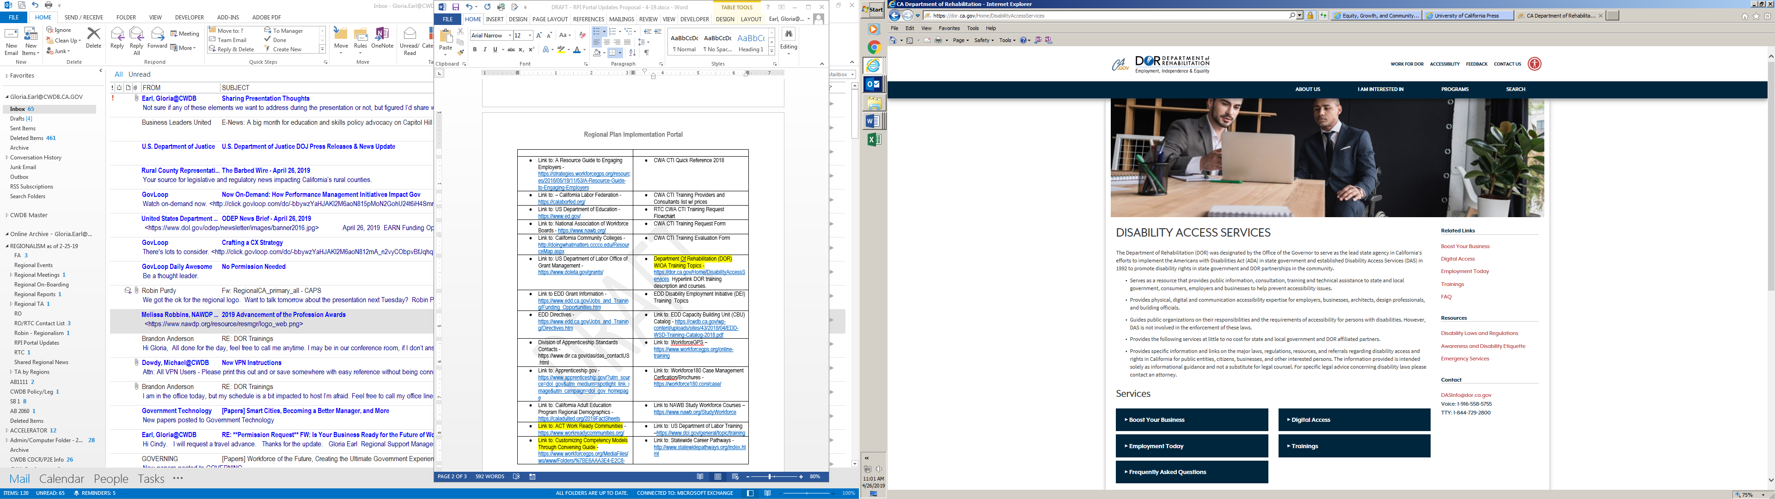

CLICK ON TRAINING

CLICK ON TRAINING

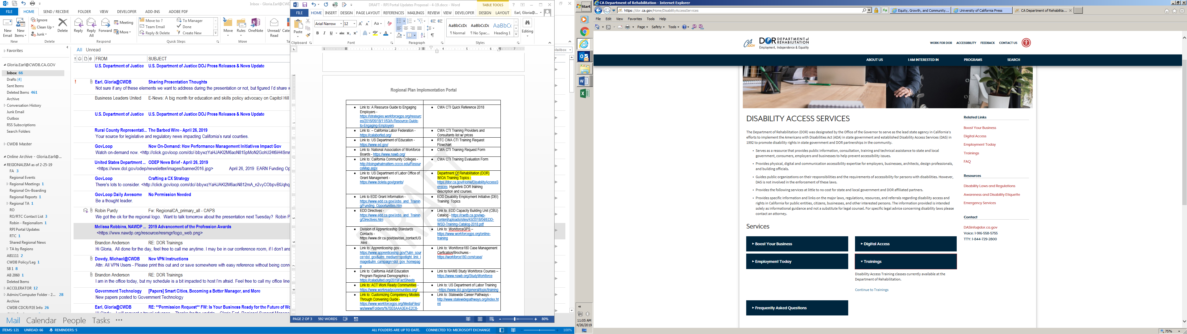

CLICK ON TRAINING AGAIN

CLICK ON TRAINING AGAIN

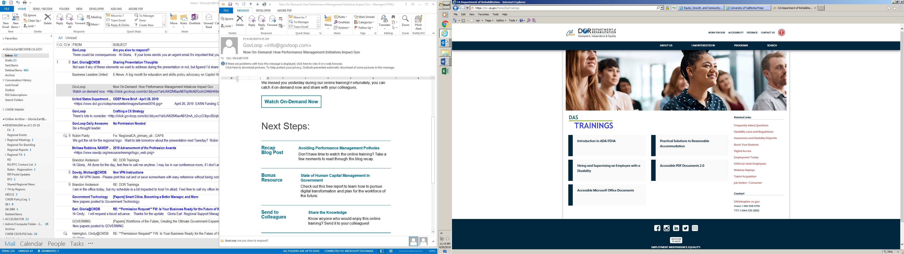

Select desired training topics to obtaining training information/objective(s). Training request can be sent via email: [Workforce.Development@dor.ca.gov](mailto:Workforce.Development@dor.ca.gov) or by calling: 1-916-558-5423